**SREELAKSHMI ENERGY SYSTEMS PVT. LTD. WEBSITE DETAILS**

**PAGES**

1. HOME
2. ABOUT US
3. SOLUTIONS
4. LPG PRODUCTS
5. INDUSTRIES (NO DATA)
6. GALLERY
7. CLIENTS
8. CONTACT US

**HOME PAGE**

* HEADER WITH LOGO AND QUICK CONTACT DETAILS
* SLIDER WITH OPTIONS
* BRIEF ABOUT THE COMPANY
* REQUEST A CALL BACK (FORM)
* CTA BUTTONS
* SOCIAL MEDIA LINKS

**ABOUT US PAGE**

**Welcome to**

**Sreelakshmi Energy Systems Pvt. Ltd.**

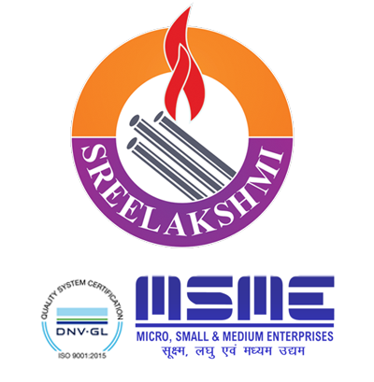

We introduce ourselves as one of the pioneer companies in the field of Oil and Gas pipeline projects, City Gas Distribution Network. We are a well-established organisation having its office at Kochi in Kerala. We began our operations in the year 2006. We are an ISO certified company for quality management system.

Understanding the ever-growing need for Piped Gas System in high-rise buildings, Hospitality and Industrial sectors we have evolved ourselves as an EPCM ( Engineering , Procurement & Construction Management) solution provider  
We have made an impact by creating state of the art Technology for Industrial, Hospitality and Residential projects with International quality standards and unmatched Customer service. We believe in delivering the best products that exceeds our client’s expectations.

What we do -

We undertake projects on turn-key basis. We also offer solutions by providing expert guidance on Planning, Design and Installation with mandatory safety and quality standards as per customers requirement.  
Our installations conform to Oil Industry Safety Directorate (OISD 162), IS:6044 Part I-2018 Gas cylinder rules 2004/2015, Controller of explosives (PESO), Department of Industrial Safety And Health (DISH) Factory Act Rule No.13  
  
We are the part of a group having 30 years of experience in Oil & Gas retail business having a turnover of over Rs.700 million.  
  
We have completed more than 500 Projects since inception and many more Projects are in progress. With our deep dedication and hard work we have emerged as the reliable partner to many renowned companies.

The complete Solution Company:-

Our tie up with all three marketing companies, IOAGPL and others has helped us to expand our operations to new areas. From planning to commissioning, our projects are executed with utmost perfection, assured quality and on time delivery with unmatched after sales service.

## Message from the Director

"May I take this opportunity to thank our valued customers, whose continued patronage and confidence in our work inspires us to extend the best of services and enables us to provide value for their money. I always wanted to push my company to more prosperous milestones. I always perceived my company as a unit that could make a difference with its quality and competitively priced products. Taking a path less travelled, I expanded Sreelakshmi energy Systems Pvt. Ltd., a part of a group having 30 years of experience in oil & gas retail business completing many more LPG projects including installations for industries, hotels & restaurants, shopping malls, education institutions and more than 75,000 residential apartments.

We are committed to total customer satisfaction by identifying their specific needs, translating them into quality products and providing dependable after-sales-services.

For all our success, the management is indebted to on most dedicated team of employees who are always ready to accept new ideas and concepts, shoulder responsibilities and meet challenges triggering the growth of the organization and customer satisfaction.

Once again, we seek continued patronage of our valued customers and thank our well-wishers who have contributed to the growth of the organisation. The journey of Sreelakshmi Energy Systems Pvt.Ltd. is never ending. But with the support of my team and clients, I am confident that the company will continue to scale milestones of excellence for years to come."

## Quality Policy

We follow the guidelines as per ISO 9001-2015. Our policy has been derived to meet various Customer requirements such as,

* Designing as per customer’s requirements
* Continuous improvement in design and installation skills.
* Extending quick service at competitive price with excellent quality.
* Materials and equipment’s conforming to international standards.
* After sales service and support to ensure customer satisfaction.

## Our Mission

Provide the best service to our customers; strive to exceed customer’s needs & expectations. Establish long standing relationship with customers by providing high quality products & services at reasonable price.

## Infrastructure

## Our infrastructure includes all Modern Machinery & Equipment required for Pipeline Installations, and a team of dedicated and experienced Engineers and highly skilled Technicians. Our Materials Department ensures Quality materials are used at Project sites. We impart regular training to our technicians and engineers through external agencies to keep them updated on latest installation practices, technology & Safety aspects to ensure safe working atmosphere at project sites.

**SOLUTION PAGE**

* **FUEL CONVERSION**
* **COMMERCIAL GAS PIPELINE INSTALLATION**
* **RETICULATED GAS SYSTEM**
* **GAS LEAKGE DETECTING SYSTEM AND MONITORING**
* **PIPED NATURAL GAS INSTALLATION (RESIDENTIAL, COMMERICIAL AND INDUSTRIAL)**
* **AMC AND MAINTENANC**

1. **FUEL CONVERSION**

# What is Fuel Conversion -

Fuel Conversion is to convert Furnace Oil / HSD / Coal fired furnaces and Boilers to LPG fired system.

Rising costs of Furnace Oil, Diesel, and Coal coupled with handling, storage, spillage, adulteration cost is forcing progressive companies to look for alternatives, also with the environment laws becoming more stringent and consumers' increasing awareness for reducing pollution, companies are now opting for greener technologies.

Advantages :-

* Gaseous fuel does not require any vaporization, hence no heat loss from the combustion process.
* Fuel atomization is absent with Gaseous fuel, hence efficiency improves by 5% to 8%
* Low or negligible maintenance of equipment’s. High equipment life span
* Environmentally friendly as emissions are low
* Ash content in Solid / Liquid fuels leads to low net availability of burnable fuel
* Reduces expensive electric power consumption due to low requirement of blowers etc.
* No Vaporization loss from storage tanks
* High Equipment life span. Low maintenance of equipment’s and hence lower running cost
* No spillage, theft losses or adulteration possible because of pressurized storage
* Enhanced end product quality

Our team of Engineers work in collaboration with Oil Marketing Companies ( IOCL, BPCL,HPCL) to carry out cost benefit analysis, designing the system, obtaining statutory approvals, commissioning the system, third party inspection and provide after commissioning support to the client We have undertaken and executed around 250 such conversion projects in the past 5 years, introducing Green Engineering and also bringing about significant energy cost savings to our clients.

[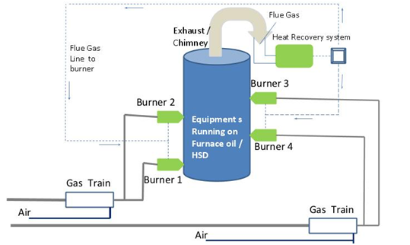](https://sreelakshmienergysystems.com/assets/images/services/fuel_conversion.png)

Fig -1

LPG is supplied through a network of pipelines, from a centralized cylinder bank / manifold system or a Bulk Installation.

##### Applications

* Chemical & Petrochemical (medium scale)
* Steel & Metal Industry
* Agriculture dyers
* Textile / Fiber
* Automotive
* Ceramic
* Painting / Powder Coating
* Food Processing
* Hot Mix Plants
* Foundry

1. **COMMERCIAL GAS PIPELINE INSTALLATION**

In Commercial Gas pipeline Installation there are basically two types of System, LOT (Liquid off Take System) and VOT (Vapour Off take System)

##### **LOT SYSTEM (LIQUID OFF TAKE)**

**LOT system** is an advance concept in multi cylinder installations which overcomes lots of demerits of Bulk LPG system & conventional Manifold (VOT) systems. This system is widely used in commercial & industrial applications only where high pressure is required & not for domestic purpose.

##### The system can be divided into into 4 sections.

* At the cylinder section in an LOT cylinder with adapters and Manifold. Once the Cylinder valve is turned on, the liquid LPG is sucked in through the adapter and is passed through to the manifold. The pressure here is the same as cylinder pressure of 5-6 bar (kg/cm2).
* The liquid then enters the vapouriser section. Here as the liquid LPG travels through the vapouriser, it gets heated and starts to evaporate and form vapour. A solenoid valve is kept on vapouriser inlet to ensure that the liquid flow is stopped in case the vapouriser does not reach the set temperature.
* Next the vapour enters the regulating section / Gas train. Here the pressure of the vapour is reduced to set pressure of 2 bar from 5.5 bar. This can be further regulated to suit customer needs and distributed through a network of pipelines to the burner.
* Gas leak detection system and solenoid cut off system can be provided for additional safety.

##### **VOT SYSTEM (VAPOUR OFF TAKE)**

It is the most common type of installation used mostly where the maximum LPG off-take is less than 60Kg per hour. Because of its design and working principle, this type of installation is advised only to consumers with comparatively low LPG usage.

##### The system can be divided into into 4 sections.

* In the **cylinder section** the LPG in the cylinder vapourises and is carried into the manifold by means of an adaptor and an LPG hose. There are two manifolds of one active and the other standby cylinder banks.

The vapour is then passed through a regulator which acts as the **first stage regulation**. Here the pressure is reduced to 2 bar from 5 bar.

* The vapour then passes through an LPG strainer before entering a **second stage regulation** which further regulates the pressure of the vapour.
* As the vapour moves along, it enters the **distribution section and through network of pipelines** it is distributed to individual outlets.

1. **RETICULATED GAS SYSTEM**

Reticulated system is a method of distribution of Domestic LPG in housing colonies and apartments complexes through a pipeline network from a centralized cylinder bank or bulk storage to customer’s kitchen . The concept of the LPG Reticulated System is the best alternative to the conventional LPG cylinder distribution system. With increase in demand for LPG in the domestic and commercial sectors reticulated LPG supply is the best alternative

1. **GAS LEAKAGE DETECTION AND MONITORING**

Leak Detection System is mandatory in LPG Cylinder Banks as per the amended IS 6044 Part 1 2018 Revision. Gas detection Systems are used for detecting leakage in the Gas Banks. The Microprocessor based control panel and sensor module provide timely warning when the leak attains dangerous levels.

Detection systems are available for gases **like**LPG (Butane / Propane), Natural Gas, Ammonia (NH3), Acetylene (C2H2), Carbon Monoxide (CO), and Hydrogen (H2)

##### There are different Types of Leak detection systems available in the market depending on individual requirement. The LPG Leak detection sensors are of three types:-

* 1. **Standalone Sensor** – This is a plug-in type of sensor. The alarm is placed inside the domestic kitchen. It can also be connected to solenoid valve to cut the Gas flow.
  2. **Addressable Type Centralised System** – In this type the control panel and alarm is placed near the security / caretaker cabin. In case of any leakages the flat no / sensor no is displayed in the control panel. The control panel also provides additional data monitoring and management by making itself compatible with devices like BMS or other security management devices.
  3. **Analogue Type Sensor System** – This is a simple system which activates the alarms when gas concentrations approach dangerous levels. This system is mainly used in Gas bank.

**PIPE NATURAL GAS (PNG)**

Piped Natural gas (PNG) is used for Domestic, Commercial and Industrial Consumption. PNG has several distinctions to its credit-of being pollution free, economical and safer fuel being few of them. PNG is not stored at one place but is continuously supplied through the pipeline from a source. Natural Gas is one of the cleanest modern day fuels. Being efficient and non-polluting it has emerged as the fuel of choice.

**Benefits of PNG**

• More Affordable

• Comfortable

• Clean

• Uninterrupted Supply

• Cost-effective

• Safe

Piped Natural Gas (PNG) is distributed through a pipeline network which has all the safety features, assuring uninterrupted supply.

A strong emphasis has been laid on the expansion of City Gas Distribution (CGD) network across the country. The distribution network would enable supply cleaner cooking fuel to household, industries as well as transportation fuel to vehicles

**City Gas Distribution Project:-**

1. City gas distribution project play a significant role in achieving the shift towards a gas-based economy, with natural gas as the next-generation, cheaper and environment friendly fossil fuel.
2. Indian CGD sector is improving our lives by providing climate friendly, economically cheap and sustainable fuel for future.Sreelakshmi Energy Systems Pvt. Ltd. has been appointed as one of the main contractors by IOAGPL and AD&P Pratham to carry out Piped Natural Gas Distribution in the city G’s of Thrissur, Ernakulam, Alappuzha, Kollam, Trivandrum. We have served more than 600 domestic customers and 10 commercial customers till date.
3. The main scope comprises of Direct Marketing with customers, laying of underground Medium Density Polyethylene (MDPE) mains & service pipelines, installation of Service Regulators, valve chamber, Meter Regulating Station etc.
4. 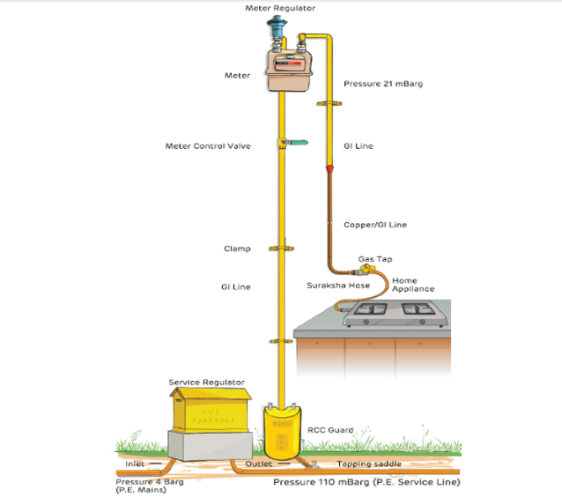

**Fig -2**

1. **PERIODIC MAINTENNANCE & AFTER SALES SERVICE**

After Sales service is part of our company Strategy. We at Sreelakshmi Energy Systems provide after sales support for higher customer satisfaction.

As per IS: 6044 Part I- 2018 standards its mandatory to carry out periodic inspections in LPG Installations.

#### **We provide two types of maintenance plan to our Customers**

##### **Annual Maintenance Contract ( AMC)**

This is a yearly contract plan. In this Plan we carry out periodic inspection every four month. Our Scope of work is as follows :-

* Checking of cylinder rooms, regulating station, common area and kitchen (Reticulated Installations).
* Checking of Gas Rooms, regulating station, cleaning and servicing of LPG Pots, Filters and Vapouriers (Commercial/Industrial Installations).
* In case of any emergencies our team will attend to all breakdowns within 24 working hours during the contract period.
* The Labour charges will be free of cost during the AMC Period.
* General inspection and replacement of signage boards will be carried out during this contract.
* Special Discount will be provided for materials (in case of any defects) during this contract period.

##### **One Time Inspection Plan**

In this plan, our scope of work will be limited to one time inspection of the following area

* Checking of cylinder rooms, regulating station, common area and kitchen (Reticulated Installations).
* Checking of Gas Rooms, regulating station, cleaning and servicing of LPG Pots, Filters and Vapouriers (Commercial/Industrial Installations).

**CONTACT US**

* **Head Office:**37/ 628, Ponevazhi Road,  
  Edappally P.O, Kochi - 24, Kerala, India
* **Zonal Office:**14/10, Welcome Colony, Anna Nagar Western Extn., Chennai - 600 101
* **Project Offices:**Lucknow & Bangalore
* [Mob: 9562418266](tel:+9562418266), [Ph: 0484 2989297](tel:+04842989297)
* **LPG Division:**[+91 9562418266](tel:+919562418266), [+91 9562418246](tel:+919562418246), [marketing@sreelakshmi.info](mailto:marketing@sreelakshmi.info)
* **Piped Natural Gas Division:**[+91 9072634770](tel:+919072634770), [+91 9072650010](tel:+919072650010), [pngprojects@sreelakshmi.info](mailto:pngprojects@sreelakshmi.info)
* **Retail Sales:** [+91 9072600199](mailto:+91%209072600199), [retailsales@sreelakshmi.info](mailto:retailsales@sreelakshmi.info)
* **Instagram:** [sreelakshmienergysystems](https://www.instagram.com/sreelakshmienergysystems/)

# **Facebook:** Sreelakshmi Energy Systems Pvt Ltd.

* **Twitter:** @SreelakshmiLtd